**How to Restart or Reconnect the Uipath Bot**

1. Open Uipath Assistant Application.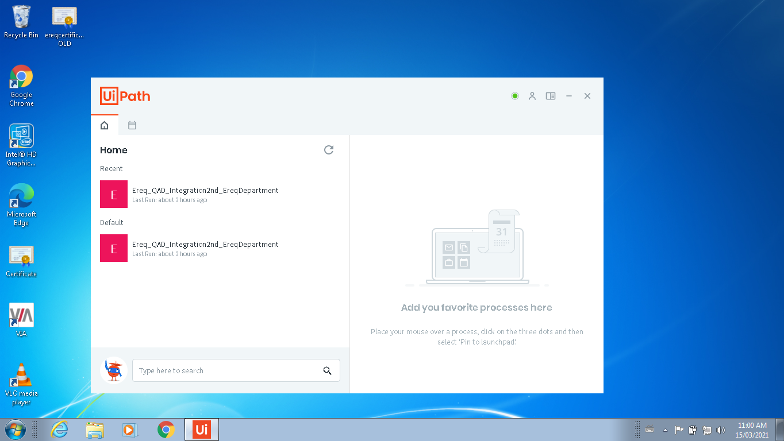2. Click on Show hidden icons on taskbar. 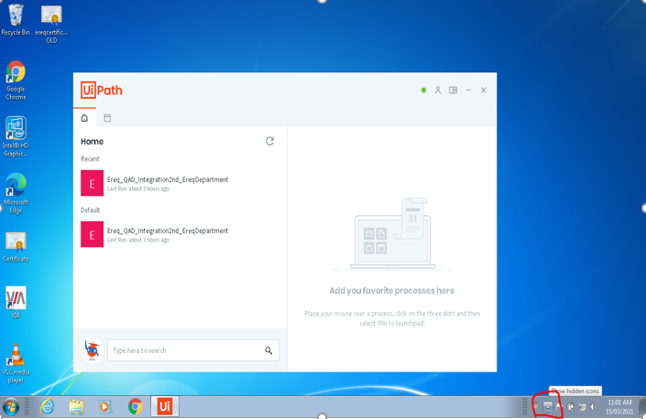

3. Right click on below Uipath Mono. 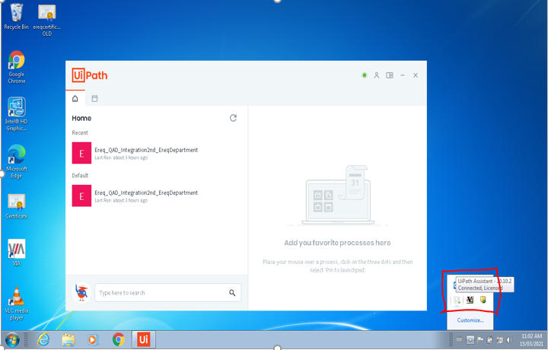

4. Double Click on orchestrator settings.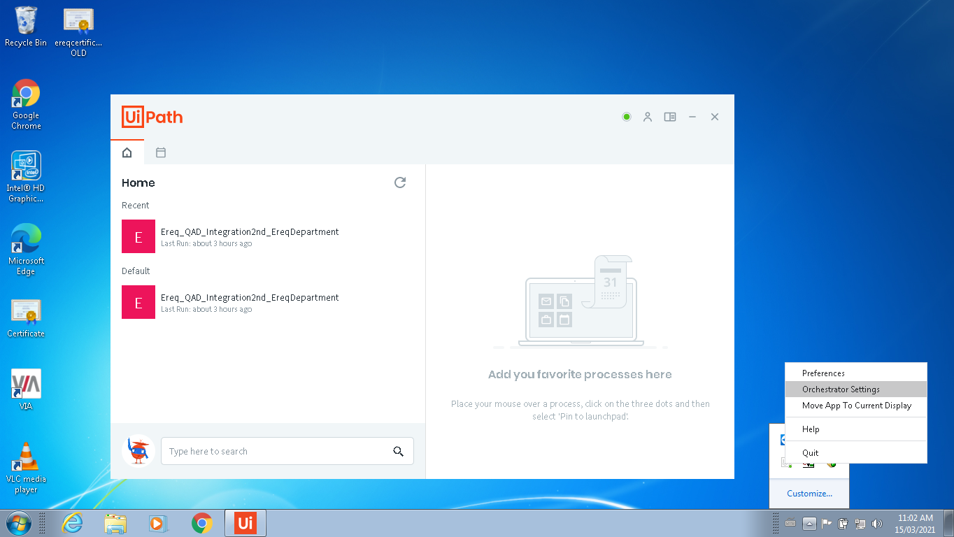

5. Check the orchestrator configuration Status, it should be Connected Licensed. If not then follow below steps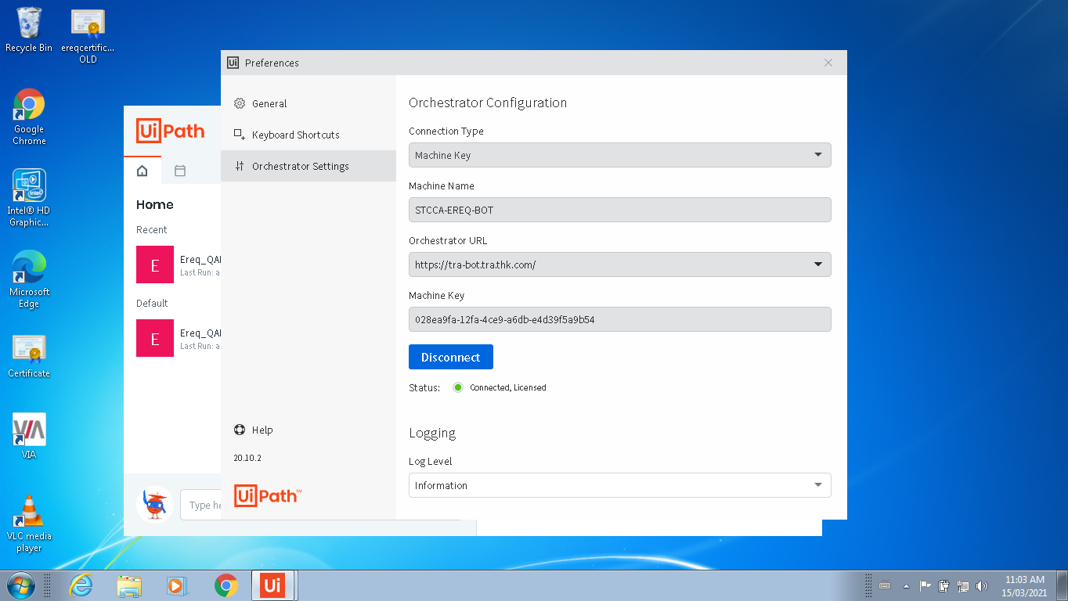

6. If not connected then enter the below details:

Configuration Type – Machine Key

Machine Name – STCCA-EREQ-BOT

Orchestrator URL - <https://tra-bot.tra.thk.com/>

Machine Key - 028ea9fa-12fa-4ce9-a6db-e4d39f5a9b54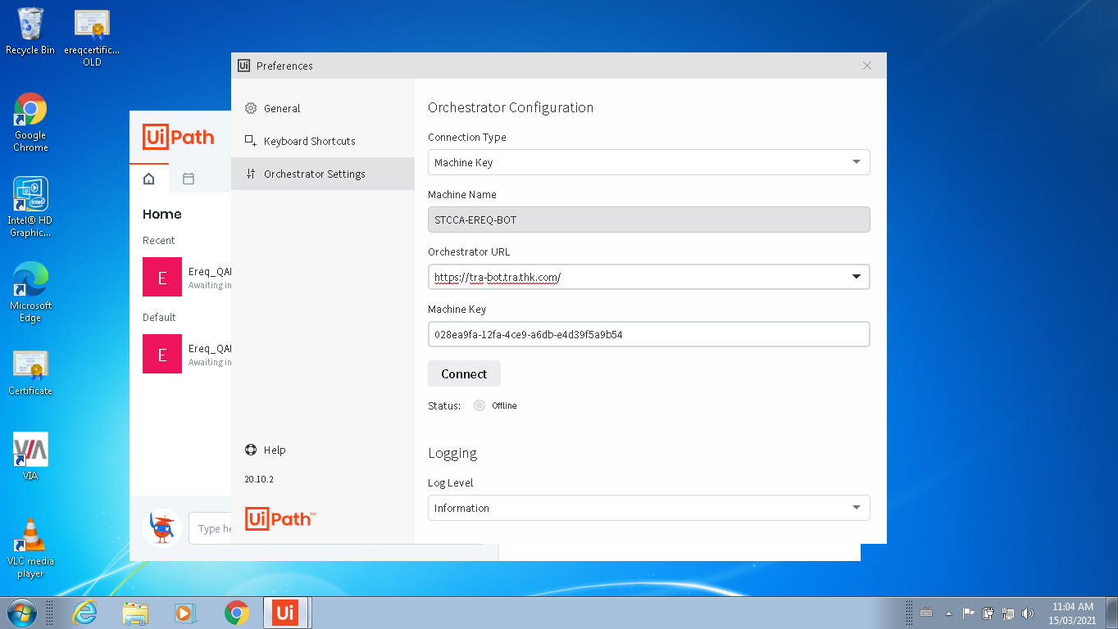

7. Click on Connect Button and check the status.

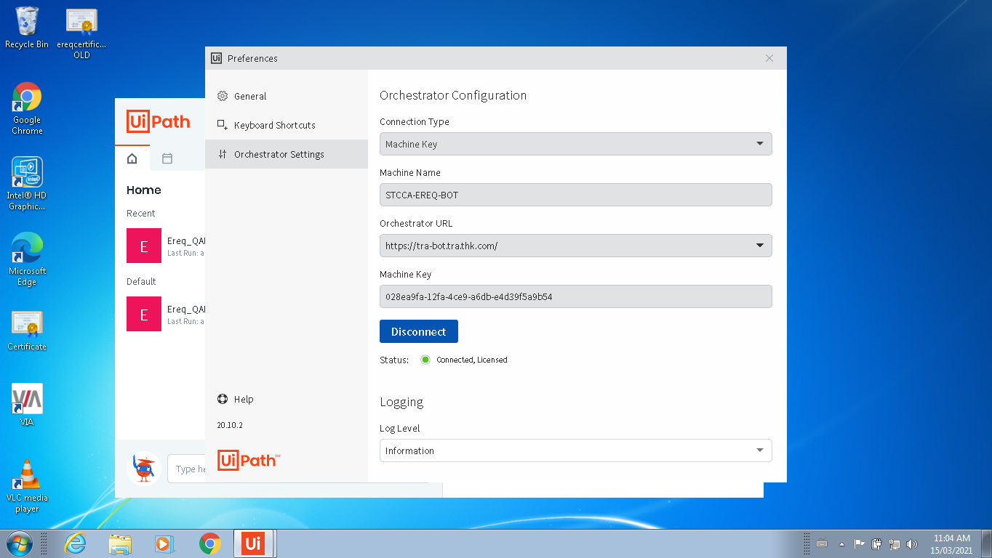

8. Close the orchestrator configuration setting window.